**MURPHYS SANITARY DISTRICT**

*“Dedicated to providing a safe wastewater collection and treatment service at fair and reasonable rates for the community of Murphys, preserving and protecting our environment for future generations.”*

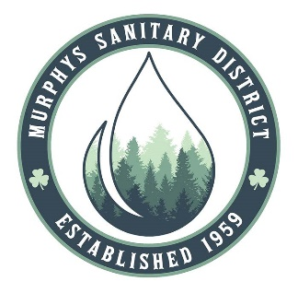

**Finance Committee Meeting** **MSD District Office**

Wednesday, October 8, 2024 15 Ernest Street, Suite A

10:00 a.m. Murphys, CA 95247

**AGENDA**

*Finance meetings are open to the public and the following alternative is available*

*for those who wish to participate in the meeting virtually:*

Microsoft Teams [Need help?](https://aka.ms/JoinTeamsMeeting?omkt=en-US)

[Join the meeting now](https://teams.microsoft.com/l/meetup-join/19%3ameeting_ZmJiODQzNTYtOTAxNi00MjkxLWI2YWUtYmRmMDc5ZjNhZmFj%40thread.v2/0?context=%7b%22Tid%22%3a%22e4b52f19-66de-4e7e-b1ee-ec350c1f61e7%22%2c%22Oid%22%3a%225f60ca67-c30d-402e-ac02-8d5ff3ead740%22%7d)

Meeting ID: 211 429 425 209

Passcode: NvPokp

Dial in by phone

[+1 872-242-9031,,863851152#](tel:+18722429031,,863851152) United States, Chicago

[Find a local number](https://dialin.teams.microsoft.com/70c1df61-bee4-4f72-a8cb-49d8ef07b7ba?id=863851152)

Phone conference ID: 863 851 152#

**CALL MEETING TO ORDER/PLEDGE OF ALLEGIANCE**

1. **Roll Call**
2. **Public Comment-***(Limit 5 minutes per person) on items not appearing on agenda. At this time, members of the public may address the Board on any non-agendized item. The public is encouraged to work through staff to place items on the agenda for Board consideration. No action can be taken on matters not listed on the agenda.*

## New Business

*The Committee may consider the items below for recommendation to the Board of Directors in a public meeting. Public comment is allowed on each individual agenda item listed below.*

1. Review/Discuss the Investment Ladder spreadsheet
2. Review/Discuss Investment Account Options
3. **Director/Staff Comments**
4. **Next Finance Committee Meeting: TBD**
5. **Adjournment**

In compliance with the Americans with Disabilities Act, if you need special assistance to participate in this meeting, please contact the **Murphys Sanitary District at 209-728-3094**. Notification in advance of the meeting will enable MSD to make reasonable arrangements to ensure accessibility to this meeting. Any documents that are made available to the Board before or at the meeting, not privileged or otherwise protected from disclosure, and related to agenda items, will be made available at MSD for review by the public.